43256 - Write the final poster’s title here, not too long, please (use the style “Title 1”)
Author1Surname Initials ¹, Author2Surname Initials ¹, Author3Surname Initials ¹, Author4Surname Initials ², … AuthorNSurname Initials ² (use the style “Authors”)
¹ Institution1, Country1 ² Institution2, Country2, (add more affiliations if needed). Correspondence: corresponding.author@email.edu (use the style “Affiliations”)

Introduction (For the section titles, please use the style “Title 2”.)
Please make sure that your paper do not exceed 2 pages. Do not change the margins, do not change the text fonts, use the Word styles contained in this file. Do not add any fancy style.
For the text body, please use the style “Text”.
Here write about the background of your research, its motivations, the problem(s) you are starting from and you want to contribute to solving.
This part should not be too long, it should just illustrate the main reason why your study could be relevant and what are the starting premises.
If you want to add a reference, use the square brackets and a number [1]. If you want to add two or more references, use the square brackets and a number for each reference, separated by a comma, without spaces [1,2,3]. All and only the papers cited in the text must appear in the list of references.

Objectives
For the text body, please use the style “Text”. Here write about the specific purpose of your study. Here write about the specific purpose of your study. Here write about the specific purpose of your study.
Here write about the specific purpose of your study. Here write about the specific purpose of your study. Here write about the specific purpose of your study.

Materials and methods
For the text body, please use the style “Text”. Here explain how you reached the objectives that you stated above. Write about where the data come from and how you collected, processed, and analysed them.
If you want to add a few references, use the square brackets and the numbers separated by a comma [2,3]. All and only the papers cited in the text must appear in the list of references.
Here write about where the data come from and how you collected, processed, and analysed them. Here write about where the data come from and how you collected, processed, and analysed them.

Results
For the text body, please use the style “Text”. Here write about the specific results, findings, outcomes, outputs of your study.
If you want to add a few references, use the square brackets and the numbers separated by a comma [4,5]. All and only the papers cited in the text must appear in the list of references.
Example of a Table, which must be referenced in the text (Table 1). The Table must follow the reference and must be put in the most convenient postition in the text.
Table 1. Example of table illustrating the main results (use the style “Caption”)
Description | Case 1 | Case 1 | Case 1 | Totals
- Item A | (use the style “TableText”)
- Item B
- Item C
Totals
Source: indicate the source, e.g., author’s data, or another publication (with reference) (use the style “TableText”)

You may want to use numbered lists or bullet points.
- Numbered Point 1
- Numbered Point 2
Use them only if strictly necessary, since they use a lot of space.
- Bullet point 1
- Bullet point 2
- Bullet point 3
If it is necessary to add a picture, a figure, or a graph, please reference it in the text (Figure 1) and use this formatting.
Figure 1. Example of a figure illustrating the main results (use the style “Caption”)
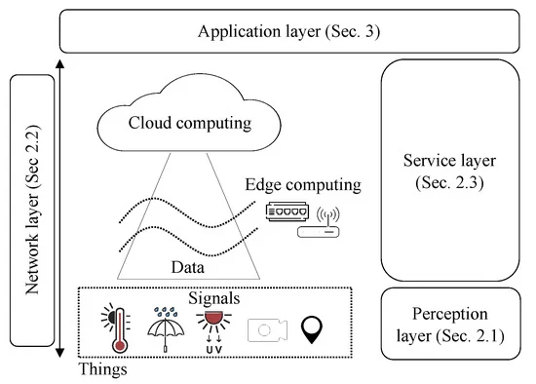 (use the style “TableText”)
Source: indicate the figure’s source, e.g., author’s data, or another publication (with reference) [7]

Discussion and conclusions
For the text body, please use the style “Text”. Here you can compare the study to previous ones and state what could be the impact/consequences of the new findings on research, business, policy-making
If you want to add a few references, use the square brackets and the numbers separated by a comma [6,7]. All and only the papers cited in the text must appear in the list of references.

Here you can compare the study to previous ones and state what could be the impact/consequences of the new findings on research, business, policy-making
Here you can compare the study to previous ones and state what could be the impact/consequences of the new findings on research, business, policy-making

Acknowledgements
For the text body, please use the style “Text”. Here you can acknowledge the contribution of other people, conflicts of interest statements, or any information about funding.

References
1. Medici M, Pedersen SM, Canavari M, et al. (2021) A web-tool for calculating the economic performance of precision agriculture technology. Computers and Electronics in Agriculture 181: 1–14.
2. Mattetti M, Medici M, Canavari M, et al. (2022) CANBUS-enabled activity-based costing for leveraging farm management. Computers and Electronics in Agriculture 194: 106792.
3. Medici M, Dooley D, Canavari M (2022) PestOn: An Ontology to Make Pesticides Information Easily Accessible and Interoperable. Sustainability 14: 6673.
4. Canavari M, Medici M, Wongprawmas R, et al. (2021) A Path Model of the Intention to Adopt Variable Rate Irrigation in Northeast Italy. Sustainability 13: 1879.
5. Fountas S, Carli G, Sørensen CG, et al. (2015) Farm management information systems: Current situation and future perspectives. Computers and Electronics in Agriculture 115: 40–50.
6. Pedersen SM, Medici M, Anken T, et al. (2019) Financial and environmental performance of integrated precision farming systems, Precision Agriculture 2019 - Papers Presented at the 12th European Conference on Precision Agriculture, ECPA 2019, 833–839.
7. Vitali G, Francia M, Golfarelli M, et al. (2021) Crop Management with the IoT: an Interdisciplinary Survey. Agronomy 11: 1–18.

